BLINKIT DATA SQL QUERIES AND RESULTS.

--1 Check the number of lines

SELECT COUNT(*) AS total_row_count

FROM BlinkIT_Data

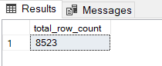

--2 Explore the data

SELECT * FROM BlinkIT_Data

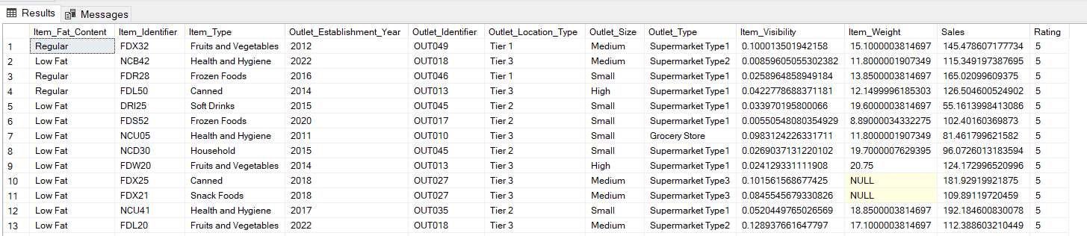

--3 need to updae this col with the uniform value. convert lower cases to upper cases.

UPDATE BlinkIT_Data

SET Item_Fat_Content = 'Low Fat'

WHERE Item_Fat_Content = 'low fat' OR Item_Fat_Content = 'LF'

--4 now we will update the other cols but with different approach, using case statements.

UPDATE BlinkIT_Data

SET Item_Fat_Content =

CASE

WHEN Item_Fat_Content IN ('LF','low fat') THEN 'Low Fat'

WHEN Item_Fat_Content = 'reg' THEN 'Regular'

ELSE Item_Fat_Content

END

--5 lets check whether the values have been updated.

SELECT DISTINCT(Item_Fat_Content) FROM BlinkIT_Data

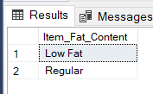

--6 Total sales in millions

SELECT CAST(SUM(Sales)/1000000 AS DECIMAL(10,2)) AS Total_sales_Million

FROM BlinkIT_Data

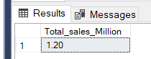

--7 Average Sales

SELECT ROUND(AVG(Sales),0) AS Average_sales

FROM BlinkIT_Data

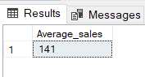

--8 Number of items

SELECT COUNT( DISTINCT Item_Type) AS Number_of_items

FROM BlinkIT_Data

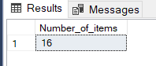

--9 Average Rating

SELECT CAST(AVG(Rating) AS DECIMAL(10,2)) AS Average_rating

FROM BlinkIT_Data

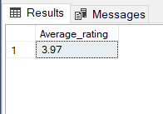

--10 Total sales for low fat items.

SELECT ROUND(SUM(Sales),0) AS total_sales_for_LOW_FAT

FROM BlinkIT_Data

WHERE Item_Fat_Content = 'Low Fat'

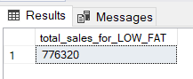

--11 Total sales for outlet establishment year (2022)

SELECT CAST(SUM(Sales)/1000000 AS decimal(10,2)) AS sales_for_2022

FROM BlinkIT_Data

WHERE Outlet_Establishment_year = '2022'

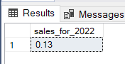

--12 Sales by fat content

SELECT Item_Fat_Content, ROUND(SUM(Sales),0) AS Sales

FROM BlinkIT_Data

GROUP BY Item_Fat_Content

